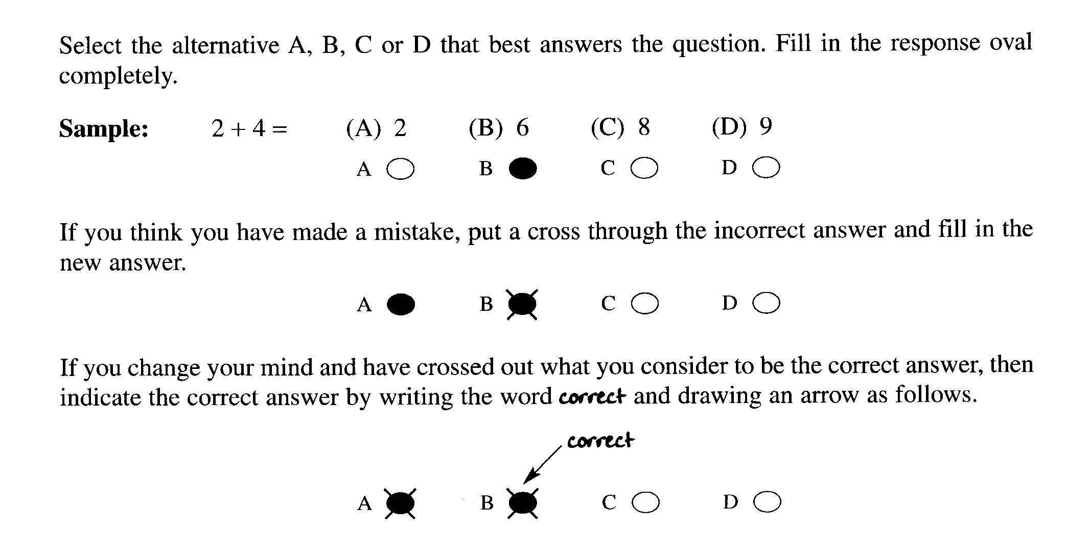
Section A: Multiple Choice (1 mark each)

Write your answer on the response grid on page 2

1.Which statement is correct concerning the use of a catalyst in the Haber Process?

(A) A catalyst enables a lower reaction temperature to be used.
(B) A catalyst produces ammonia of greater purity.
(C) A catalyst speeds up the forward reaction and slows down the reverse reaction.
(D) A catalyst removes ammonia from the product mixture allowing the equilibrium to shift to the right.

2. What is the name of the compound below?

H F Cl
| | |
H ⎯ C ⎯ C ⎯ C ⎯H
| | |
H H F

(A) 1-chloro-1,2-difluoropropane
(B) 3-chloro-2,3 – difluoropropane
(C) 1,2-difluoro-1-chloropropane
(D) 1-chloro-1,2-fluoropropane

3. If Professor Le Châtelier visited an ammonia factory which combination of variables would he advise to
maximise production?

(A) low pressure and low temperature
(B) low pressure and high temperature
(C) high pressure and low temperature
(D) high pressure and high temperature

4. Sydney Water tests a sample of water at Warragamba Dam. The results are shown in the table…

Aluminium  (μg L ^{–1}) | Total chlorine  (mg L ^{–1}) | Fluoride  (mg L ^{–1}) | Iron  (μg L ^{–1}) | Manganese  (μg L ^{–1})
< 10 | 1.52 | 1.11 | < 20 | 6

Which chemical species could be efficiently assayed using AAS?

(A) Total chlorine
(B) Total chlorine and fluoride
(C) Aluminium, iron and manganese
(D) Aluminium, total chlorine, fluoride, iron and manganese

5. What is the purpose of adding chlorine to domestic water supplies?

(A) To reduce the pH of the water
(B) To remove the heavy metal ions like lead from the water.
(C) To clarify the water
(D) To disinfect the water

6. In which layer of the atmosphere does ozone act as a UV radiation shield?

(A) mesosphere
(B) stratosphere
(C) thermosphere
(D) troposphere

Section A

Multiple Choice Answer Grid

1. A O B O C O D O

2. A O B O C O D O

3. A O B O C O D O

4. A O B O C O D O

5. A O B O C O D O

6. A O B O C O D O

Section B: Short Answer Questions

Question 7 (6 marks)

The Syntex Ammonia Corporation produces ammonia via the Haber process by mixing hydrogen and nitrogen in a 3:1 mole ratio and passing it over a promoted iron catalyst at 500°C and 200 atm. Under these conditions the yield of ammonia is 20%.

The graph shows a pair of lines for the reaction of hydrogen and nitrogen during the synthesis of ammonia…
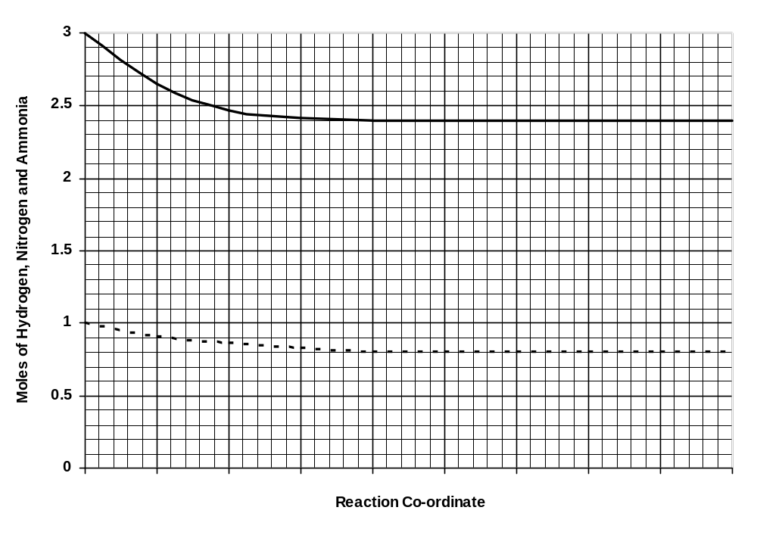
Hydrogen
Nitrogen

(a) Draw in a line showing the simultaneous production of ammonia during this process. (1 mark)

(b) Explain the effects of temperature on the production of ammonia. (4 marks)

______________________________________________________________________________

______________________________________________________________________________

______________________________________________________________________________

______________________________________________________________________________

______________________________________________________________________________

______________________________________________________________________________

______________________________________________________________________________
(c) In 1918 Fritz Haber was awarded the Nobel Prize for his ammonia process.
Why was this discovery so significant to warrant a Nobel Prize? (1 mark)

______________________________________________________________________________

______________________________________________________________________________

______________________________________________________________________________

______________________________________________________________________________

Question 7 (4 marks)

Mount Ruse® Mineral Water is analysed for the presence of iron, chloride and carbonate ions.

(a) Complete the table showing suitable test reagents and results… (3 marks)

Ion tested | Test reagent used  (name or formula) | Observed result for a positive test
iron
chloride
carbonate

(b) Mount Ruse® Mineral Water is also known to contain calcium ions.
Describe a simple test to detect calcium which does not involve a test reagent. (1 mark)

_________________________________________________________________________________

_________________________________________________________________________________

Question 8 (4 marks)

(a) Describe what is meant by a coordinate covalent bond.

…………………………………………………………………………………………………………..

……………………………………………………………………………………………………………

(b) Circle the covalent bond in the diagram of ozone.

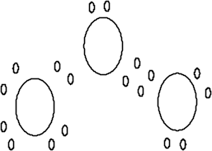

(c) Identify the type of diagram used in question (b) above.

…………………………………………………………………………………………………….

…………………………………………………………………………………………………….

(d) The diagram used in question (b) above is one way to model a molecule of ozone. State one
limitation of such a model

………………………………………………………………………………………………………

………………………………………………………………………………………………………

………………………………………………………………………………………………………

Question 9 (6 marks)

Given below is a diagram which represents the design of a microscopic membrane filter.

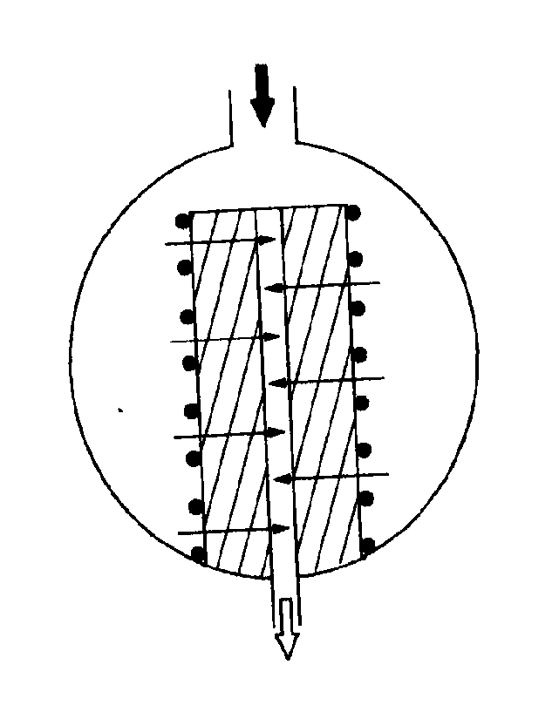.

Explain how the filter works and assess the effectiveness of this method of filtration in its use to purify
water supply

…………………………………………………………………………………………………………….

…………………………………………………………………………………………………………….

…………………………………………………………………………………………………………….

…………………………………………………………………………………………………………….

…………………………………………………………………………………………………………….

…………………………………………………………………………………………………………….

…………………………………………………………………………………………………………….

…………………………………………………………………………………………………………….

…………………………………………………………………………………………………………….

…………………………………………………………………………………………………………….

…………………………………………………………………………………………………………….

…………………………………………………………………………………………………………….

…………………………………………………………………………………………………………….

…………………………………………………………………………………………………………….

…………………………………………………………………………………………………………….

…………………………………………………………………………………………………………….
Part B: Atomic Absorption Spectrometry:

The chromium in an aqueous sample was determined by pipetting 10.0 mL of the sample into a 50.0-mL volumetric flask and diluting to volume. The solution was measured by atomic absorption along with four standard solutions of chromium. The results are given below:

Sample | Concentration, ppm | Absorbance
Standard A | 2.4 | 0.091
Standard B | 4.8 | 0.177
Standard C | 7.2 | 0.266
Standard D | 9.6 | 0.353
Unknown Cr | Unknown | 0.201

(a) Plot the data (3 marks)



(b) Calculate the concentration in mol L ^{–1} of Cr in the original sample. (3 marks)

…………………………………………………………………………………….

……………………………………………………………………………………….

………………………………………………………………………………………..

End of Test

